What is I/O in Java
- I/O means Input / Output
- Input → reading data into a program
- Output → writing data out of a program
Meaning
Java I/O allows a program to communicate with the outside world (files, keyboard, network).

Why Java I/O is Needed
Programs need to:
- Read files
- Write logs
- Accept user input
- Store data permanently
- Transfer data between systems
Without I/O → program dies when execution ends.

What is a Stream (MOST IMPORTANT)
- A stream is a flow of data
- Data moves one direction
- Sequential (not random access)
Source ---> Program ---> Destination
Interview line
A stream represents a continuous flow of data from source to destination.

Why Java Uses Stream-Based I/O
Reasons:
- Device-independent
- Works same for file, keyboard, network
- Memory efficient (process chunk-by-chunk)
Java does NOT load entire file into memory by default.

Types of Streams (HIGH LEVEL)
Two main classifications:
- Based on direction
- Based on data type

Input Stream vs Output Stream
Input Stream
- Reads data
- Direction: source → program
Example:
System.in

Output Stream
- Writes data
- Direction: program → destination
Example:
System.out

Byte Stream vs Character Stream (VERY IMPORTANT)

Byte Streams
- Handle raw binary data
- Read/write 8-bit bytes
- Base classes:
  - InputStream
  - OutputStream
Used for:
- Images
- Audio
- Video
- Binary files

Character Streams
- Handle text data
- Read/write 16-bit characters
- Unicode support
- Base classes:
  - Reader
  - Writer
Used for:
- Text files
- Logs
- Configuration files

Interview Comparison
- Byte stream → machine-friendly
- Character stream → human-readable

Java I/O Class Hierarchy (MENTAL MODEL)
Object
|
----------------
| |
InputStream OutputStream
|
FileInputStream
Object
|
Reader
|
FileReader
Interview tip
InputStream/OutputStream → bytes
Reader/Writer → characters

Blocking I/O Concept
- Java I/O is blocking
- Thread waits until:
  - Data is available
  - Read/write finishes
Example:
in.read(); // blocks until data arrives
Why important
- Impacts performance
- Reason for NIO introduction later

Buffering Concept (PERFORMANCE CORE)
Without Buffer
- Each read/write → OS call
- Very slow
With Buffer
- Data collected in memory
- Fewer system calls
- Faster execution
Analogy
Buffer = bucket
Without buffer = spoon

What is a Buffer
- Temporary memory
- Stores chunk of data
- Improves performance drastically
Used via:
- BufferedInputStream
- BufferedOutputStream
- BufferedReader
- BufferedWriter

File Handling Basics (Preview)
Java treats:
- File
- Directory
As File object
File f = new File("data.txt");
File object does NOT read/write data
It only represents file metadata.

Checked Exceptions in I/O
Most I/O operations throw checked exceptions
- IOException
- FileNotFoundException
Meaning
Compiler forces you to handle file errors explicitly.

Basic Console I/O Example
Reading a Single Character
int ch = System.in.read();
System.out.println((char) ch);
- Reads 1 byte
- Blocking call
- Throws IOException

Writing Output
System.out.println("Hello I/O");
Uses OutputStream internally.

Why Scanner Is NOT Part of Core I/O
- Scanner uses I/O internally
- But adds parsing + regex
- Slower than BufferedReader
Interview insight:
Scanner = convenience, BufferedReader = performance

Common Beginner Confusions
- File class reads data
- Stream stores full file
- Reader works for binary
- BufferedReader required
Correct understanding:
- File → metadata only
- Stream → flow of data
- Buffer → performance optimization

Real-Time Mapping
Requirement | Stream Type
Read image | FileInputStream
Write log | FileWriter
Fast text read | BufferedReader
Binary copy | BufferedInputStream
Primitive data | DataInputStream

Interview Questions from Module 0
- What is a stream?
- Why Java I/O is blocking?
- Byte vs Character stream?
- Why buffering improves performance?
- File vs FileInputStream?

ONE-LINE INTERVIEW SUMMARY
Java I/O is stream-based, where data flows sequentially between source and destination using byte or character streams, with buffering used to improve performance.

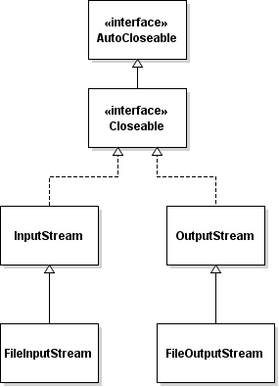

MODULE 1 – BYTE STREAMS (java.io)

1. What are Byte Streams
- Byte streams process raw binary data
- Read/write 8-bit bytes
- Base abstract classes:
  - InputStream
  - OutputStream
Meaning
Byte streams are used when data is not text or encoding must be preserved exactly.

2. When to Use Byte Streams
- Images (jpg, png)
- Audio / Video
- PDF / ZIP
- Any binary format
- Low-level file copy

3. Byte Stream Class Hierarchy (Core)
InputStream
├─ FileInputStream
├─ BufferedInputStream
└─ DataInputStream

OutputStream
├─ FileOutputStream
├─ BufferedOutputStream
└─ DataOutputStream

4. FileInputStream (Read Bytes from File)
Definition
- Reads bytes from a file
- One byte at a time or in blocks
- Blocking I/O

Basic Read (Byte-by-Byte)
import java.io.FileInputStream;
import java.io.IOException;

public class FileInputStreamDemo {
public static void main(String[] args) throws IOException {

FileInputStream fis = new FileInputStream("input.bin");
int data;

while ((data = fis.read()) != -1) {
System.out.print(data + " ");
}

fis.close();
}
}
- read() returns int
- -1 means end of file
- Time → Slow (many OS calls)

Read Using Byte Array (Recommended)
import java.io.FileInputStream;
import java.io.IOException;

public class FileInputStreamBlock {
public static void main(String[] args) throws IOException {

FileInputStream fis = new FileInputStream("input.bin");
byte[] buffer = new byte[1024];
int bytesRead;

while ((bytesRead = fis.read(buffer)) != -1) {
for (int i = 0; i < bytesRead; i++) {
System.out.print(buffer[i] + " ");
}
}

fis.close();
}
}
- Fewer system calls
- Much faster

5. FileOutputStream (Write Bytes to File)
Definition
- Writes bytes to a file
- Overwrites by default
- Append mode available

Basic Write
import java.io.FileOutputStream;
import java.io.IOException;

public class FileOutputStreamDemo {
public static void main(String[] args) throws IOException {

FileOutputStream fos = new FileOutputStream("output.bin");
fos.write(65);
fos.write(66);
fos.write(67);

fos.close();
}
}
Writes ASCII bytes: A B C

Append Mode
FileOutputStream fos = new FileOutputStream("output.bin", true);

Write Byte Array
byte[] data = {10, 20, 30, 40};
fos.write(data);

6. File Copy (REAL-TIME USE CASE)
Without Buffer (Slow)
FileInputStream fis = new FileInputStream("source.jpg");
FileOutputStream fos = new FileOutputStream("dest.jpg");

int b;
while ((b = fis.read()) != -1) {
fos.write(b);
}

fis.close();
fos.close();

With Buffer (Fast & Correct Way)
FileInputStream fis = new FileInputStream("source.jpg");
FileOutputStream fos = new FileOutputStream("dest.jpg");

byte[] buffer = new byte[4096];
int bytesRead;

while ((bytesRead = fis.read(buffer)) != -1) {
fos.write(buffer, 0, bytesRead);
}

fis.close();
fos.close();
Interview line
Always use buffered block reads for file copy.

7. BufferedInputStream & BufferedOutputStream
Why Buffered Streams
- Wrap another stream
- Reduce disk I/O calls
- Major performance boost

BufferedInputStream Example
import java.io.*;

public class BufferedInputDemo {
public static void main(String[] args) throws IOException {

BufferedInputStream bis =
new BufferedInputStream(new FileInputStream("input.bin"));

int data;
while ((data = bis.read()) != -1) {
System.out.print(data + " ");
}

bis.close();
}
}

BufferedOutputStream Example
import java.io.*;

public class BufferedOutputDemo {
public static void main(String[] args) throws IOException {

BufferedOutputStream bos =
new BufferedOutputStream(new FileOutputStream("out.bin"));

bos.write(100);
bos.write(101);
bos.write(102);

bos.flush(); // force write
bos.close();
}
}

8. flush() vs close()
- flush() → forces data to destination
- close() → flush + release resource
Rule
Always close streams.

9. Performance Comparison
Approach | Speed
Byte-by-byte | Very slow
Byte array | Fast
Buffered stream | Fastest

10. Common Mistakes
- Forgetting to close streams
- Using FileReader for binary ❌
- Reading byte-by-byte for large files
- Not handling exceptions

11. try-with-resources (BEST PRACTICE)
try (FileInputStream fis = new FileInputStream("a.bin");
FileOutputStream fos = new FileOutputStream("b.bin")) {

byte[] buf = new byte[1024];
int n;
while ((n = fis.read(buf)) != -1) {
fos.write(buf, 0, n);
}
}
- Auto-close
- Cleaner
- Interview recommended

12. Real-Time Byte Stream Use Cases
- File backup utility
- Image uploader
- Video streaming
- ZIP extractor

13. Interview Questions from Byte Streams
- FileInputStream vs FileReader?
- Why buffering improves speed?
- read() returns int why?
- flush() vs close()?
- Append mode use?

ONE-LINE INTERVIEW SUMMARY
Byte streams handle raw binary data using InputStream and OutputStream, with buffered block I/O providing the best performance for real-world file operations.

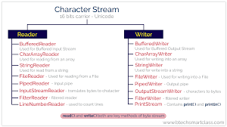

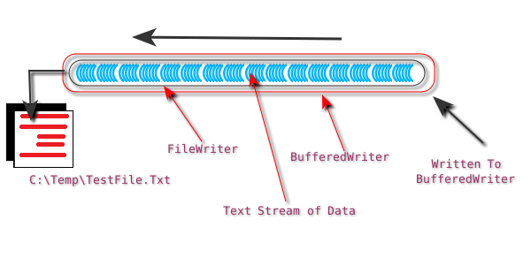

MODULE 2 – CHARACTER STREAMS (java.io)

What are Character Streams
- Character streams handle text data
- Work with 16-bit Unicode characters
- Automatically handle character encoding
- Base abstract classes:
  - Reader
  - Writer
Meaning
Character streams are designed for human-readable text, not raw binary.

Why Character Streams are Needed
Problems with byte streams for text:
- Encoding issues
- Multi-byte characters break
- Manual conversion needed
Character streams solve:
- Unicode support
- Platform independence
- Clean text processing

Byte Stream vs Character Stream (INTERVIEW CORE)
- Byte Stream
  - 8-bit
  - Binary-safe
  - No encoding awareness
- Character Stream
  - 16-bit
  - Unicode-aware
  - Text-safe
Interview line
Use byte streams for binary data, character streams for text data.

Character Stream Class Hierarchy
Reader
├─ FileReader
├─ BufferedReader
└─ InputStreamReader

Writer
├─ FileWriter
├─ BufferedWriter
└─ OutputStreamWriter

FileReader (Read Text File)
Definition
- Reads characters from a file
- Uses default system encoding
- Low-level character stream

Basic FileReader Example
import java.io.FileReader;
import java.io.IOException;

public class FileReaderDemo {
public static void main(String[] args) throws IOException {

FileReader fr = new FileReader("input.txt");
int ch;

while ((ch = fr.read()) != -1) {
System.out.print((char) ch);
}

fr.close();
}
}
- read() returns int
- -1 → end of file
- Slower for large files

FileWriter (Write Text File)
Definition
- Writes characters to file
- Overwrites by default
- Supports append mode

Basic FileWriter Example
import java.io.FileWriter;
import java.io.IOException;

public class FileWriterDemo {
public static void main(String[] args) throws IOException {

FileWriter fw = new FileWriter("output.txt");
fw.write("Hello Java I/O");
fw.write('\n');
fw.write("Character Streams");

fw.close();
}
}

Append Mode
FileWriter fw = new FileWriter("output.txt", true);

Limitations of FileReader / FileWriter
- No buffering
- One character at a time
- Poor performance for large files
- No readLine() method

BUFFERED CHARACTER STREAMS (MOST USED)

BufferedReader (HIGHLY IMPORTANT)
Definition
- Wraps another Reader
- Reads large chunks internally
- Provides readLine()

BufferedReader Example
import java.io.*;

public class BufferedReaderDemo {
public static void main(String[] args) throws IOException {

BufferedReader br =
new BufferedReader(new FileReader("input.txt"));

String line;
while ((line = br.readLine()) != null) {
System.out.println(line);
}

br.close();
}
}
Why preferred
- Fast
- Clean
- Line-based reading

BufferedWriter
Definition
- Wraps a Writer
- Writes text efficiently
- Supports newLine()

BufferedWriter Example
import java.io.*;

public class BufferedWriterDemo {
public static void main(String[] args) throws IOException {

BufferedWriter bw =
new BufferedWriter(new FileWriter("output.txt"));

bw.write("Java I/O");
bw.newLine();
bw.write("Buffered Writer Example");

bw.close();
}
}

flush() in Character Streams
bw.flush();
- Pushes buffered data to file
- Needed when stream stays open

File Copy (TEXT FILE – REAL TIME)
import java.io.*;

public class TextFileCopy {
public static void main(String[] args) throws IOException {

BufferedReader br =
new BufferedReader(new FileReader("source.txt"));
BufferedWriter bw =
new BufferedWriter(new FileWriter("dest.txt"));

String line;
while ((line = br.readLine()) != null) {
bw.write(line);
bw.newLine();
}

br.close();
bw.close();
}
}

InputStreamReader (BRIDGE STREAM)
Definition
- Converts byte stream → character stream
- Handles encoding explicitly

Why Needed
- Reading text from:
  - Network
  - Keyboard
  - Binary source

Example (Keyboard Input)
import java.io.*;

public class InputStreamReaderDemo {
public static void main(String[] args) throws IOException {

BufferedReader br =
new BufferedReader(new InputStreamReader(System.in));

System.out.print("Enter name: ");
String name = br.readLine();

System.out.println("Hello " + name);
}
}

OutputStreamWriter
Definition
- Converts character data to byte stream
- Used when writing text to binary destination

Writer writer =
new OutputStreamWriter(new FileOutputStream("out.txt"));
writer.write("Hello World");
writer.close();

Encoding Awareness (IMPORTANT)
- FileReader uses default charset
- InputStreamReader allows explicit charset
new InputStreamReader(
new FileInputStream("file.txt"), "UTF-8");
Interview insight:
Encoding bugs are silent and dangerous.

Performance Comparison
Stream | Performance
FileReader | Slow
BufferedReader | Fast
Scanner | Slowest

Common Mistakes
- Using FileInputStream for text
- Ignoring encoding
- Not closing streams
- Using Scanner for large files

try-with-resources (BEST PRACTICE)
try (BufferedReader br =
new BufferedReader(new FileReader("a.txt"))) {
System.out.println(br.readLine());
}

Real-Time Use Cases
- Log file reading
- Config file parsing
- CSV processing
- Report generation

Interview Questions
- FileReader vs BufferedReader?
- Why InputStreamReader needed?
- Scanner vs BufferedReader?
- How Java handles encoding?
- Character vs Byte stream?

ONE-LINE INTERVIEW SUMMARY
Character streams process text data using Reader and Writer classes, with BufferedReader and BufferedWriter providing high-performance, encoding-safe text I/O.

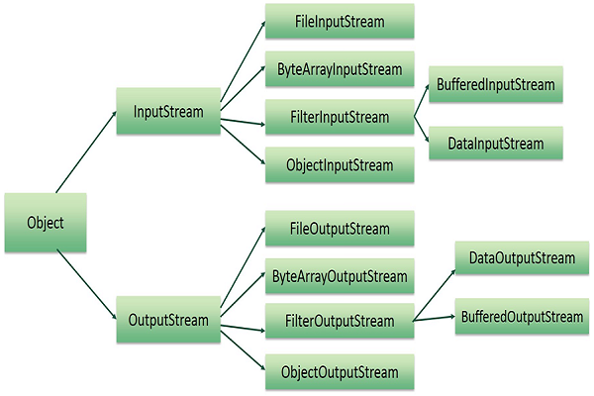
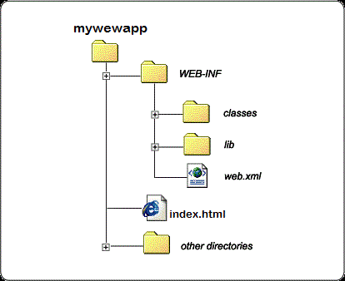
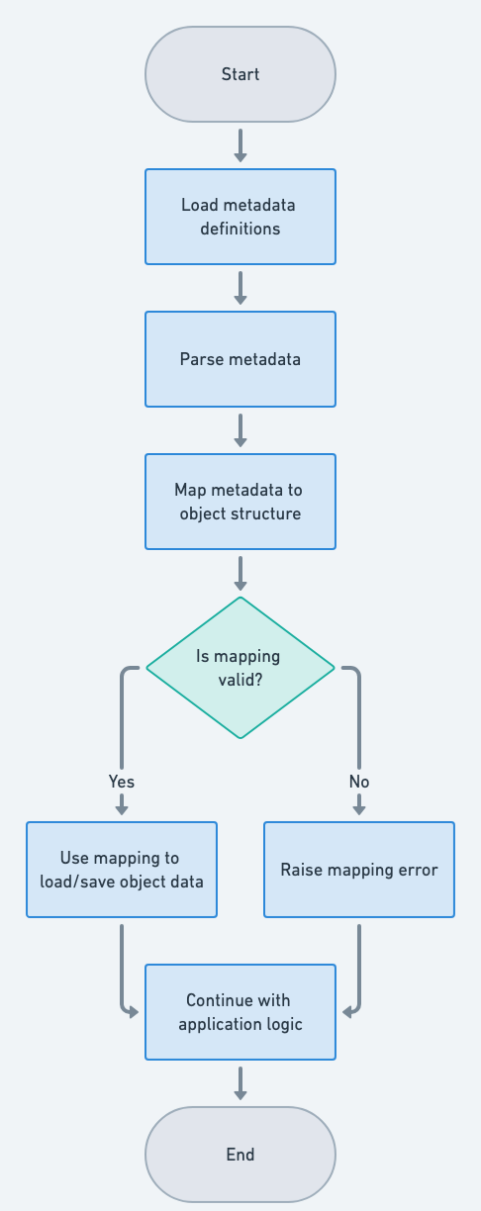

MODULE 3 – FILE HANDLING (java.io.File)

1What is File Class
- File represents a file or directory path
- It does NOT read or write data
- It is used to:
  - Create files/directories
  - Delete files
  - Rename files
  - Get file metadata
Meaning
File is a path abstraction, not a data stream.

Why File Class is Needed
Without File:
- No way to check file exists
- No directory handling
- No metadata access
- No file management
Streams → data
File → file system control

Important Interview Clarification
- File does NOT read/write content
- FileInputStream / FileReader read/write content
Interview line:
File handles file system operations, streams handle data flow.

Creating a File Object
import java.io.File;

File file = new File("data.txt");
- No file created yet
- Just a path reference

File vs Directory
File f1 = new File("test.txt"); // file
File f2 = new File("logs"); // directory
Same class → different meaning based on path.

Creating a New File
import java.io.File;
import java.io.IOException;

public class CreateFileDemo {
public static void main(String[] args) throws IOException {

File file = new File("sample.txt");

if (file.createNewFile()) {
System.out.println("File created");
} else {
System.out.println("File already exists");
}
}
}
- Creates empty file
- Throws IOException

Creating a Directory
Single Directory
File dir = new File("myDir");
dir.mkdir();

Multiple Directories
File dirs = new File("parent/child/grandchild");
dirs.mkdirs();

Check File Properties (Metadata)
File file = new File("sample.txt");

System.out.println(file.exists());
System.out.println(file.isFile());
System.out.println(file.isDirectory());
System.out.println(file.canRead());
System.out.println(file.canWrite());
System.out.println(file.length());
System.out.println(file.lastModified());

Absolute vs Relative Path
File f = new File("sample.txt");

System.out.println(f.getPath());
System.out.println(f.getAbsolutePath());
Interview insight:
- Relative → project dependent
- Absolute → full OS path

Renaming a File
File oldFile = new File("old.txt");
File newFile = new File("new.txt");

oldFile.renameTo(newFile);

Deleting a File
File file = new File("temp.txt");

if (file.delete()) {
System.out.println("Deleted");
}
File must be closed before delete.

Listing Files in a Directory
File dir = new File("logs");

String[] files = dir.list();
for (String name : files) {
System.out.println(name);
}

Listing Files with Details
File dir = new File("logs");

File[] files = dir.listFiles();
for (File f : files) {
System.out.println(f.getName() + " : " + f.length());
}

Filter Files (Manual Filtering)
File dir = new File("logs");

File[] files = dir.listFiles();
for (File f : files) {
if (f.getName().endsWith(".log")) {
System.out.println(f.getName());
}
}

Recursive Directory Traversal (ADVANCED)
void listAll(File dir) {
File[] files = dir.listFiles();
if (files == null) return;

for (File f : files) {
if (f.isDirectory()) {
listAll(f);
} else {
System.out.println(f.getAbsolutePath());
}
}
}

Real-Time Example – Log Cleaner
void deleteOldLogs(File dir, long days) {
long cutoff = System.currentTimeMillis()
- days * 24 * 60 * 60 * 1000;

File[] files = dir.listFiles();
if (files == null) return;

for (File f : files) {
if (f.isFile() && f.lastModified() < cutoff) {
f.delete();
}
}
}

File Permissions (OS Dependent)
file.setReadable(true);
file.setWritable(false);
file.setExecutable(true);

Common Mistakes
- Expecting File to read content
- Ignoring exists() check
- Deleting open files
- Assuming rename always works

Performance Notes
- File operations are fast
- Disk-dependent
- No buffering needed (no data flow)

Interview Questions
- File vs FileInputStream?
- File vs Path (NIO)?
- mkdir vs mkdirs?
- list vs listFiles?
- Why delete fails sometimes?

ONE-LINE INTERVIEW SUMMARY
The File class represents file system paths and metadata, enabling file and directory management without performing actual data I/O operations.

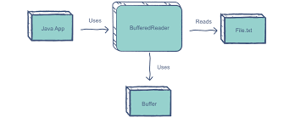

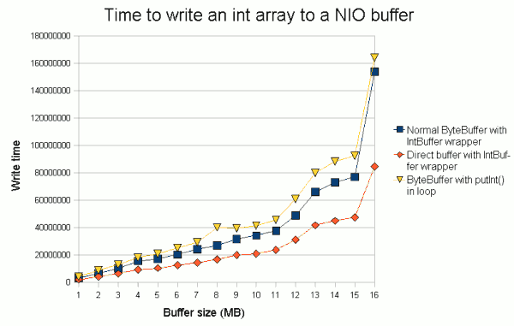

MODULE 4 – BUFFERED I/O (java.io)

What is Buffered I/O
- Buffered I/O adds a memory buffer between program and disk
- Data is read/written in chunks, not byte/char by byte/char
Meaning
Buffered I/O reduces expensive disk I/O calls by batching data in memory.

Why Buffered I/O is Needed
Without buffering:
- Every read/write → OS system call
- Very slow for large files
With buffering:
- Fewer system calls
- Massive performance improvement

Where Buffer Sits (Internal View)
Program ↔ Buffer (RAM) ↔ Disk
- Program talks to buffer
- Buffer talks to disk

Buffered I/O Classes
Byte Buffered Streams
- BufferedInputStream
- BufferedOutputStream
Character Buffered Streams
- BufferedReader
- BufferedWriter

BufferedInputStream
Definition
- Wraps an InputStream
- Reads a large block internally
- Serves data from memory buffer

Basic Example
import java.io.*;

public class BufferedInputStreamDemo {
public static void main(String[] args) throws IOException {

BufferedInputStream bis =
new BufferedInputStream(new FileInputStream("input.bin"));

int b;
while ((b = bis.read()) != -1) {
System.out.print(b + " ");
}

bis.close();
}
}

BufferedOutputStream
Definition
- Wraps an OutputStream
- Stores data in buffer
- Writes to disk only when buffer fills or flushed

Example
import java.io.*;

public class BufferedOutputStreamDemo {
public static void main(String[] args) throws IOException {

BufferedOutputStream bos =
new BufferedOutputStream(new FileOutputStream("out.bin"));

for (int i = 0; i < 1000; i++) {
bos.write(i);
}

bos.flush(); // important
bos.close();
}
}

flush() – VERY IMPORTANT
- Forces buffer → disk
- Required when stream remains open
bos.flush();
Rule
Always flush before close if data correctness matters.

BufferedReader (MOST USED CLASS)
Definition
- Wraps a Reader
- Provides line-based reading
- Very fast for text files

BufferedReader Example
import java.io.*;

public class BufferedReaderDemo {
public static void main(String[] args) throws IOException {

BufferedReader br =
new BufferedReader(new FileReader("input.txt"));

String line;
while ((line = br.readLine()) != null) {
System.out.println(line);
}

br.close();
}
}

How readLine() Works (Internal Idea)
- Reads large char array into buffer
- Searches for \n
- Returns one line at a time
No repeated disk access → fast.

BufferedWriter
Definition
- Wraps a Writer
- Efficient text writing
- Platform-independent line separator

Example
import java.io.*;

public class BufferedWriterDemo {
public static void main(String[] args) throws IOException {

BufferedWriter bw =
new BufferedWriter(new FileWriter("output.txt"));

bw.write("Java Buffered I/O");
bw.newLine();
bw.write("Fast and Efficient");

bw.close();
}
}

Buffered vs Unbuffered (TEXT FILE COPY)
Unbuffered (Slow)
FileReader fr = new FileReader("a.txt");
FileWriter fw = new FileWriter("b.txt");

int c;
while ((c = fr.read()) != -1) {
fw.write(c);
}

fr.close();
fw.close();

Buffered (Fast & Correct)
BufferedReader br =
new BufferedReader(new FileReader("a.txt"));
BufferedWriter bw =
new BufferedWriter(new FileWriter("b.txt"));

String line;
while ((line = br.readLine()) != null) {
bw.write(line);
bw.newLine();
}

br.close();
bw.close();

Performance Comparison (INTERVIEW GOLD)
Approach | Speed
FileReader/FileWriter | Slow
Byte-by-byte | Very Slow
Block read | Fast
Buffered Streams | Fastest

Buffer Size (ADVANCED)
Default:
- Usually 8 KB
Custom buffer size:
new BufferedInputStream(
new FileInputStream("a.bin"), 16 * 1024);
Use case:
- Large file processing

BufferedReader vs Scanner (INTERVIEW)
- BufferedReader
  - Faster
  - No parsing
  - Large files
- Scanner
  - Easy
  - Regex-based
  - Slow
Interview line
BufferedReader is preferred for performance-critical input.

Real-Time Use Cases
- Log file reading
- CSV processing
- Report generation
- File copy utilities
- Server-side I/O

Common Mistakes
- Forgetting flush
- Wrapping stream multiple times
- Using Scanner for large files
- Not closing buffered streams

try-with-resources (BEST PRACTICE)
try (BufferedReader br =
new BufferedReader(new FileReader("a.txt"));
BufferedWriter bw =
new BufferedWriter(new FileWriter("b.txt"))) {

String line;
while ((line = br.readLine()) != null) {
bw.write(line);
bw.newLine();
}
}
Auto-close + safe.

Buffered Streams DO NOT Change Data
- They optimize performance only
- No data modification
- Transparent wrapper

Interview Questions
- Why buffering improves speed?
- BufferedReader vs FileReader?
- flush() vs close()?
- read() vs readLine()?
- Default buffer size?

ONE-LINE INTERVIEW SUMMARY
Buffered I/O improves Java I/O performance by reducing disk access through in-memory buffering, making it essential for large file and high-throughput operations.

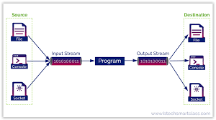
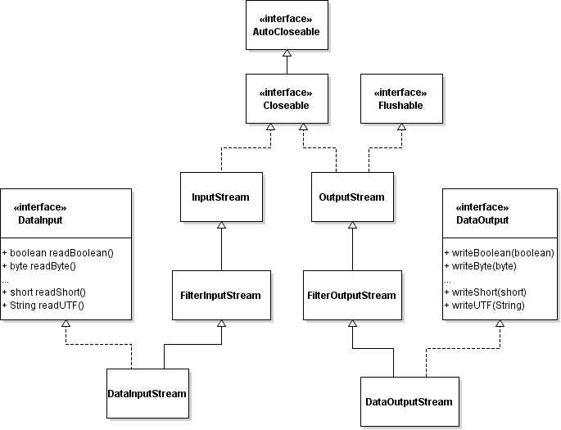
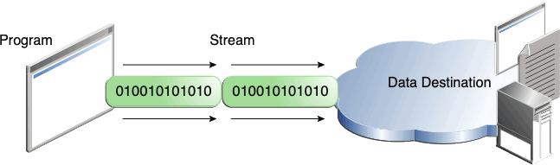

MODULE 5 – DATA STREAMS (java.io)

What are Data Streams
- Data Streams are used to read and write Java primitive data types
- They preserve binary format + data type
- Core classes:
  - DataInputStream
  - DataOutputStream
Meaning
Data streams allow Java programs to store and retrieve primitive values in a machine-independent binary format.

Why Data Streams are Needed
Problems without Data Streams:
- Writing primitives as text → parsing overhead
- Loss of exact type
- Larger file size
Data streams solve:
- Exact type preservation
- Faster read/write
- Compact storage

Where Data Streams Fit
Program
↓
DataInputStream / DataOutputStream
↓
Buffered Stream (optional)
↓
FileInputStream / FileOutputStream
↓
Disk

Important Rule (VERY IMPORTANT)
Read order must be the SAME as write order
If order mismatches → corrupted data

DataOutputStream
Definition
- Writes Java primitive types in binary form
- Wraps an OutputStream

Supported Write Methods
- writeInt()
- writeDouble()
- writeBoolean()
- writeChar()
- writeUTF()

Basic Example – Writing Primitives
import java.io.*;

public class DataOutputDemo {
public static void main(String[] args) throws IOException {

DataOutputStream dos =
new DataOutputStream(
new FileOutputStream("data.bin"));

dos.writeInt(101);
dos.writeDouble(99.5);
dos.writeBoolean(true);
dos.writeChar('A');
dos.writeUTF("Java I/O");

dos.close();
}
}

DataInputStream
Definition
- Reads primitive data types written by DataOutputStream
- Wraps an InputStream

Supported Read Methods
- readInt()
- readDouble()
- readBoolean()
- readChar()
- readUTF()

Basic Example – Reading Primitives
import java.io.*;

public class DataInputDemo {
public static void main(String[] args) throws IOException {

DataInputStream dis =
new DataInputStream(
new FileInputStream("data.bin"));

int id = dis.readInt();
double price = dis.readDouble();
boolean status = dis.readBoolean();
char grade = dis.readChar();
String name = dis.readUTF();

System.out.println(id);
System.out.println(price);
System.out.println(status);
System.out.println(grade);
System.out.println(name);

dis.close();
}
}

What Happens Internally
- Each primitive is converted into binary bytes
- Size is fixed:
  - int → 4 bytes
  - double → 8 bytes
  - char → 2 bytes
- Platform independent format

Write Order vs Read Order (FAIL CASE)
Wrong Read Order Example
int a = dis.readInt();
String s = dis.readUTF(); // wrong order
Result:
- Runtime exception
- Data corruption
Interview rule
Data streams are strictly sequential and order-dependent.

Using Buffered Streams with Data Streams (BEST PRACTICE)
DataOutputStream dos =
new DataOutputStream(
new BufferedOutputStream(
new FileOutputStream("data.bin")));
DataInputStream dis =
new DataInputStream(
new BufferedInputStream(
new FileInputStream("data.bin")));

Real-Time Example – Student Record Storage
Write Student Data
void writeStudent() throws IOException {
DataOutputStream dos =
new DataOutputStream(new FileOutputStream("student.dat"));

dos.writeInt(1);
dos.writeUTF("Ravi");
dos.writeDouble(85.6);

dos.close();
}

Read Student Data
void readStudent() throws IOException {
DataInputStream dis =
new DataInputStream(new FileInputStream("student.dat"));

int id = dis.readInt();
String name = dis.readUTF();
double marks = dis.readDouble();

System.out.println(id + " " + name + " " + marks);

dis.close();
}

Data Streams vs Character Streams
- Data Streams
  - Binary
  - Fast
  - Not human readable
- Character Streams
  - Text
  - Slower
  - Human readable

Data Streams vs Object Streams
- Data Streams
  - Primitives only
  - Manual structure
- Object Streams
  - Objects
  - Automatic serialization

Common Mistakes
- Changing read order
- Mixing FileReader with DataInputStream
- Forgetting buffering
- Expecting readable file

When NOT to Use Data Streams
- Human-readable files
- Config files
- Logs
- Cross-language text sharing

Interview Questions
- Why order is important in data streams?
- Data streams vs object streams?
- Can data stream read text?
- How UTF handled?
- Why binary is faster?

Time & Space Performance
- Read/Write → Very fast
- Space → Compact binary
- Overhead → Minimal

ONE-LINE INTERVIEW SUMMARY
Data streams allow efficient, type-safe binary reading and writing of Java primitive data types with strict read-write order dependency.





MODULE 5 – DATA STREAMS (java.io)

1. What are Data Streams
- Data Streams are used to read and write Java primitive data types
- They preserve binary format + data type
- Core classes:
  - DataInputStream
  - DataOutputStream
Meaning
Data streams allow Java programs to store and retrieve primitive values in a machine-independent binary format.

Why Data Streams are Needed
Problems without Data Streams:
- Writing primitives as text → parsing overhead
- Loss of exact type
- Larger file size
Data streams solve:
- Exact type preservation
- Faster read/write
- Compact storage

Where Data Streams Fit
Program
↓
DataInputStream / DataOutputStream
↓
Buffered Stream (optional)
↓
FileInputStream / FileOutputStream
↓
Disk
Important Rule (VERY IMPORTANT)
Read order must be the SAME as write order
If order mismatches → corrupted data

DataOutputStream
Definition
- Writes Java primitive types in binary form
- Wraps an OutputStream

Supported Write Methods
- writeInt()
- writeDouble()
- writeBoolean()
- writeChar()
- writeUTF()

Basic Example – Writing Primitives
import java.io.*;

public class DataOutputDemo {
public static void main(String[] args) throws IOException {

DataOutputStream dos =
new DataOutputStream(
new FileOutputStream("data.bin"));

dos.writeInt(101);
dos.writeDouble(99.5);
dos.writeBoolean(true);
dos.writeChar('A');
dos.writeUTF("Java I/O");

dos.close();
}
}

DataInputStream
Definition
- Reads primitive data types written by DataOutputStream
- Wraps an InputStream

Supported Read Methods
- readInt()
- readDouble()
- readBoolean()
- readChar()
- readUTF()

Basic Example – Reading Primitives
import java.io.*;

public class DataInputDemo {
public static void main(String[] args) throws IOException {

DataInputStream dis =
new DataInputStream(
new FileInputStream("data.bin"));

int id = dis.readInt();
double price = dis.readDouble();
boolean status = dis.readBoolean();
char grade = dis.readChar();
String name = dis.readUTF();

System.out.println(id);
System.out.println(price);
System.out.println(status);
System.out.println(grade);
System.out.println(name);

dis.close();
}
}

What Happens Internally
- Each primitive is converted into binary bytes
- Size is fixed:
  - int → 4 bytes
  - double → 8 bytes
  - char → 2 bytes
- Platform independent format

Write Order vs Read Order (FAIL CASE)
Wrong Read Order Example
int a = dis.readInt();
String s = dis.readUTF(); // wrong order
Result:
- Runtime exception
- Data corruption
Interview rule
Data streams are strictly sequential and order-dependent.

Using Buffered Streams with Data Streams (BEST PRACTICE)
DataOutputStream dos =
new DataOutputStream(
new BufferedOutputStream(
new FileOutputStream("data.bin")));
DataInputStream dis =
new DataInputStream(
new BufferedInputStream(
new FileInputStream("data.bin")));

Real-Time Example – Student Record Storage
Write Student Data
void writeStudent() throws IOException {
DataOutputStream dos =
new DataOutputStream(new FileOutputStream("student.dat"));

dos.writeInt(1);
dos.writeUTF("Ravi");
dos.writeDouble(85.6);

dos.close();
}

Read Student Data
void readStudent() throws IOException {
DataInputStream dis =
new DataInputStream(new FileInputStream("student.dat"));

int id = dis.readInt();
String name = dis.readUTF();
double marks = dis.readDouble();

System.out.println(id + " " + name + " " + marks);

dis.close();
}

Data Streams vs Character Streams
- Data Streams
  - Binary
  - Fast
  - Not human readable
- Character Streams
  - Text
  - Slower
  - Human readable

Data Streams vs Object Streams
- Data Streams
  - Primitives only
  - Manual structure
- Object Streams
  - Objects
  - Automatic serialization

Common Mistakes
- Changing read order
- Mixing FileReader with DataInputStream
- Forgetting buffering
- Expecting readable file

When NOT to Use Data Streams
- Human-readable files
- Config files
- Logs
- Cross-language text sharing

Interview Questions
- Why order is important in data streams?
- Data streams vs object streams?
- Can data stream read text?
- How UTF handled?
- Why binary is faster?

Time & Space Performance
- Read/Write → Very fast
- Space → Compact binary
- Overhead → Minimal

ONE-LINE INTERVIEW SUMMARY
Data streams allow efficient, type-safe binary reading and writing of Java primitive data types with strict read-write order dependency.

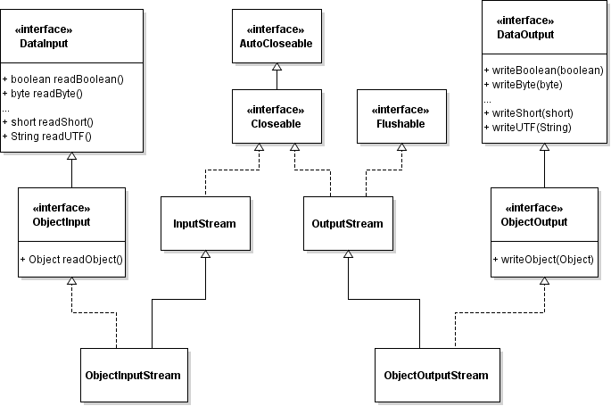

MODULE 6 – OBJECT STREAMS & SERIALIZATION (java.io)

What are Object Streams
- Object streams are used to write/read entire Java objects
- They convert objects ↔ byte stream automatically
- Core classes:
  - ObjectOutputStream
  - ObjectInputStream
Meaning
Object streams allow Java objects to be stored or transmitted as a byte stream.

What is Serialization
- Serialization = converting an object → byte stream
- Deserialization = converting byte stream → object
- Purpose:
  - Save object state
  - Send objects over network
  - Persist data

Why Serialization is Needed
Without serialization:
- Objects exist only in memory
- Lost after program ends
- Cannot be transferred between JVMs
Serialization enables:
- Persistence
- Communication
- Caching

Serializable Interface (VERY IMPORTANT)
import java.io.Serializable;

class Employee implements Serializable {
}
- Marker interface (no methods)
- Tells JVM:
This object is allowed to be serialized
Without it → NotSerializableException

Basic Serializable Class Example
import java.io.Serializable;

class Employee implements Serializable {
int id;
String name;
double salary;

Employee(int id, String name, double salary) {
this.id = id;
this.name = name;
this.salary = salary;
}
}

ObjectOutputStream (Serialization)
Definition
- Writes objects to output stream
- Wraps an OutputStream

Serialize Object Example
import java.io.*;

public class SerializeDemo {
public static void main(String[] args) throws IOException {

Employee emp = new Employee(1, "Amit", 50000);

ObjectOutputStream oos =
new ObjectOutputStream(
new FileOutputStream("emp.ser"));

oos.writeObject(emp);
oos.close();

System.out.println("Object Serialized");
}
}

ObjectInputStream (Deserialization)
Definition
- Reads objects written by ObjectOutputStream
- Wraps an InputStream

Deserialize Object Example
import java.io.*;

public class DeserializeDemo {
public static void main(String[] args)
throws IOException, ClassNotFoundException {

ObjectInputStream ois =
new ObjectInputStream(
new FileInputStream("emp.ser"));

Employee emp = (Employee) ois.readObject();
ois.close();

System.out.println(emp.id);
System.out.println(emp.name);
System.out.println(emp.salary);
}
}

What Happens Internally (INTERVIEW GOLD)
During serialization:
- JVM checks Serializable
- Converts object graph to bytes
- Stores class metadata + field values
During deserialization:
- JVM creates object without constructor
- Populates fields from byte stream

Constructor is NOT Called (IMPORTANT)
Employee emp = new Employee(); // constructor NOT called
Interview question favorite ✔

transient Keyword
Purpose
- Prevents a field from being serialized

Example
class User implements Serializable {
String username;
transient String password;

User(String u, String p) {
username = u;
password = p;
}
}

Result
username → restored
password → null

static Fields in Serialization
- static belongs to class
- Not part of object
- Not serialized

serialVersionUID (VERY IMPORTANT)
Definition
- Version control for serialized class

Why Needed
- Prevents InvalidClassException
- Ensures compatibility

Example
class Employee implements Serializable {
private static final long serialVersionUID = 1L;
}
Interview line:
Always declare serialVersionUID explicitly.

Version Mismatch Problem
- Serialize object
- Modify class (add/remove field)
- Deserialize → exception
Solution:
- Use same serialVersionUID

Object Graph Serialization
If object contains another object:
class Address implements Serializable {
String city;
}

class Person implements Serializable {
String name;
Address address;
}
- Entire object graph is serialized automatically

Non-Serializable Field Problem
class Test implements Serializable {
Thread t; // not serializable
}
Result:
- NotSerializableException
Fix:
- Make field transient

Custom Serialization (ADVANCED – CONCEPT)
Override:
- writeObject()
- readObject()
Used for:
- Encryption
- Compression
- Custom logic
(Interview awareness sufficient)

Real-Time Example – User Session Storage
class Session implements Serializable {
String user;
long loginTime;
}
Used in:
- Web servers
- Distributed systems
- Cache layers

Serialization vs Data Streams
- Object Streams
  - Objects
  - Automatic
  - More overhead
- Data Streams
  - Primitives
  - Manual
  - Faster

Serialization vs Database
- Serialization
  - Temporary storage
  - JVM dependent
- Database
  - Permanent
  - Language independent

Common Mistakes
- Forgetting Serializable
- Serializing sensitive data
- Ignoring serialVersionUID
- Using serialization for config files

Security Concerns (INTERVIEW BONUS)
- Serialized data can be tampered
- Never deserialize untrusted data
- Can lead to security vulnerabilities

Interview Questions
- What is serialization?
- Why Serializable has no methods?
- transient vs static?
- Constructor call during deserialization?
- serialVersionUID importance?

ONE-LINE INTERVIEW SUMMARY
Serialization converts Java objects into byte streams using ObjectOutputStream and ObjectInputStream, enabling persistence and transmission with strict class version control.

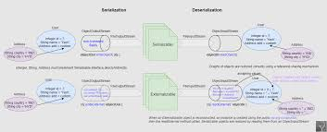

EXTERNALIZABLE – COMPLETE DEEP EXPLANATION

What is Externalizable
- Externalizable is an advanced serialization mechanism
- It gives FULL CONTROL over serialization process
- Programmer decides:
  - What to serialize
  - How to serialize
  - In which order
import java.io.Externalizable;
Meaning
Externalizable allows manual control over object serialization instead of JVM’s default mechanism.

Externalizable vs Serializable (BIG PICTURE)
- Serializable
  - Automatic serialization
  - JVM decides what to serialize
  - Less control
  - Easier to use
- Externalizable
  - Manual serialization
  - Programmer decides everything
  - More control
  - More responsibility
Interview line
Serializable is default and automatic, Externalizable is manual and controlled.

Why Externalizable is Needed
Problems with Serializable:
- Serializes all non-transient fields
- More data written than required
- Performance overhead
- Less flexibility
Externalizable solves:
- Performance optimization
- Security (exclude sensitive data)
- Custom formats
- Backward compatibility

Externalizable Interface
public interface Externalizable extends Serializable {
void writeExternal(ObjectOutput out) throws IOException;
void readExternal(ObjectInput in) throws IOException, ClassNotFoundException;
}
Key point:
- Externalizable extends Serializable
- But disables default serialization

MOST IMPORTANT RULE (INTERVIEW FAVORITE)
Public no-argument constructor is MANDATORY
Why?
- JVM uses constructor during deserialization
Without it → InvalidClassException

Serializable vs Externalizable – Constructor Behavior
- Serializable
  - Constructor NOT called
- Externalizable
  - Constructor IS called
Interview GOLD

Basic Externalizable Class Example
import java.io.Externalizable;
import java.io.IOException;
import java.io.ObjectInput;
import java.io.ObjectOutput;

public class Employee implements Externalizable {

int id;
String name;
double salary;

// Mandatory public no-arg constructor
public Employee() {
System.out.println("Public no-arg constructor called");
}

public Employee(int id, String name, double salary) {
this.id = id;
this.name = name;
this.salary = salary;
}

@Override
public void writeExternal(ObjectOutput out) throws IOException {
out.writeInt(id);
out.writeUTF(name);
// salary intentionally NOT written
}

@Override
public void readExternal(ObjectInput in)
throws IOException, ClassNotFoundException {
id = in.readInt();
name = in.readUTF();
salary = 0.0; // default
}
}

Serialization Using Externalizable
import java.io.*;

public class ExternalizableWrite {
public static void main(String[] args) throws Exception {

Employee emp = new Employee(1, "Amit", 50000);

ObjectOutputStream oos =
new ObjectOutputStream(new FileOutputStream("emp.ext"));

oos.writeObject(emp);
oos.close();

System.out.println("Object written");
}
}

Deserialization Using Externalizable
import java.io.*;

public class ExternalizableRead {
public static void main(String[] args) throws Exception {

ObjectInputStream ois =
new ObjectInputStream(new FileInputStream("emp.ext"));

Employee emp = (Employee) ois.readObject();
ois.close();

System.out.println(emp.id);
System.out.println(emp.name);
System.out.println(emp.salary); // 0.0
}
}

What Happens Internally (STEP-BY-STEP)
During Serialization
- JVM checks Externalizable
- JVM calls writeExternal()
- Programmer writes fields manually
During Deserialization
- JVM creates object using public no-arg constructor
- JVM calls readExternal()
- Programmer restores fields manually

Order Dependency (VERY IMPORTANT)
Write order MUST match read order:
out.writeInt(id);
out.writeUTF(name);
id = in.readInt();
name = in.readUTF();
Order mismatch → corrupted data

transient Keyword in Externalizable
- transient is irrelevant
- JVM ignores it
- Programmer controls serialization anyway

static Fields in Externalizable
- static fields are NOT serialized
- Same behavior as Serializable

serialVersionUID in Externalizable
- Optional but recommended
- Helps version control
private static final long serialVersionUID = 1L;

Externalizable vs Serializable – TABLE
Feature | Serializable | Externalizable
Control | JVM | Programmer
writeObject | Optional | Mandatory
readObject | Optional | Mandatory
Constructor call | No | Yes
Performance | Slower | Faster
Ease | Easy | Complex
Security | Low | High

When to Use Externalizable
- Performance-critical systems
- Large object graphs
- Sensitive data handling
- Custom binary format needed
- Backward compatibility control

When NOT to Use Externalizable
- Simple objects
- Beginners
- When default serialization is enough
- When maintenance cost is high

Real-Time Use Case Example
- Distributed cache
- Session replication
- Custom protocol design
- High-performance messaging systems

Common Mistakes (INTERVIEW TRAPS)
- Missing no-arg constructor
- Forgetting to write a field
- Wrong read/write order
- Assuming transient works

Serializable vs Externalizable – INTERVIEW ONE-LINER
Serializable provides automatic object serialization, while Externalizable gives full manual control over the serialization process with better performance and security.

MOST ASKED INTERVIEW QUESTIONS
- Why no-arg constructor is mandatory?
- Constructor called or not?
- transient behavior?
- Externalizable vs Serializable?
- Performance difference?

FINAL ONE-LINE SUMMARY
Externalizable allows complete programmer-controlled serialization by manually defining how objects are written and read, offering superior performance and flexibility over Serializable.

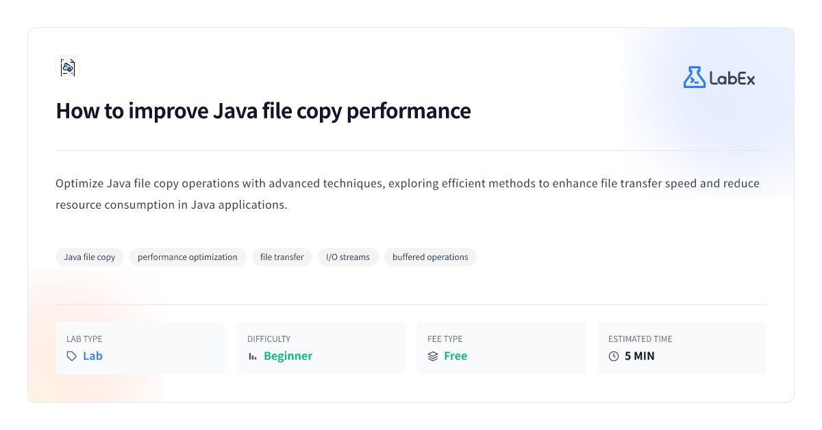
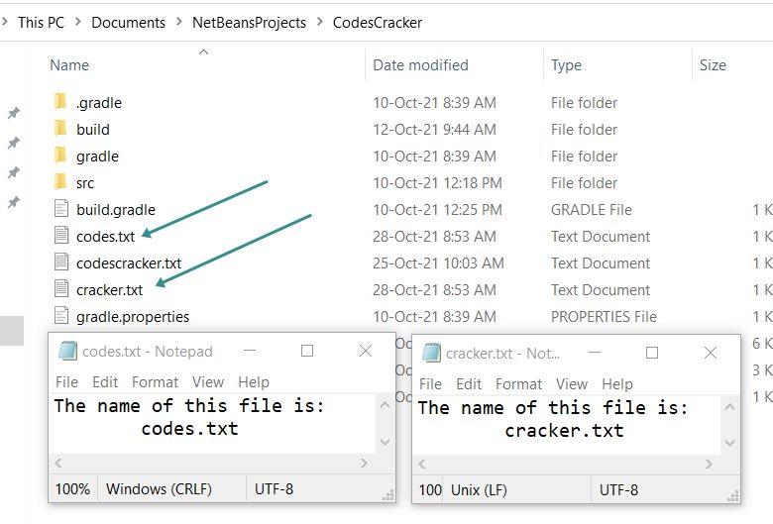

MODULE 8 – FILE COPY & REAL-TIME I/O UTILITIES

1. Why File Copy Utilities Matter
- Core backend / system task
- Tests understanding of:
  - Streams
  - Buffering
  - Performance
  - Correctness
- Very common interview & production use case
Meaning
File copy utilities validate real understanding of Java I/O fundamentals.

Types of File Copy (INTERVIEW MUST KNOW)
- Byte-by-byte copy (slow, demo only)
- Block copy (recommended)
- Buffered stream copy (best)
- Text file copy (line-by-line)
- Binary file copy (exact bytes)

TYPE 1 – BYTE-BY-BYTE FILE COPY (BASIC)
Use
- Learning only
- Never for production
import java.io.*;

public class ByteByByteCopy {
public static void main(String[] args) throws IOException {

FileInputStream fis = new FileInputStream("source.bin");
FileOutputStream fos = new FileOutputStream("dest.bin");

int b;
while ((b = fis.read()) != -1) {
fos.write(b);
}

fis.close();
fos.close();
}
}
Performance
- Very slow
- Too many disk calls

TYPE 2 – BLOCK COPY USING BYTE ARRAY (RECOMMENDED)
Use
- Standard binary copy
- Production-safe
import java.io.*;

public class BlockCopy {
public static void main(String[] args) throws IOException {

FileInputStream fis = new FileInputStream("source.bin");
FileOutputStream fos = new FileOutputStream("dest.bin");

byte[] buffer = new byte[4096];
int bytesRead;

while ((bytesRead = fis.read(buffer)) != -1) {
fos.write(buffer, 0, bytesRead);
}

fis.close();
fos.close();
}
}
Performance
- Fast
- Minimal system calls

TYPE 3 – BUFFERED STREAM COPY (BEST PRACTICE)
Use
- Large files
- High throughput
import java.io.*;

public class BufferedCopy {
public static void main(String[] args) throws IOException {

BufferedInputStream bis =
new BufferedInputStream(new FileInputStream("source.bin"));
BufferedOutputStream bos =
new BufferedOutputStream(new FileOutputStream("dest.bin"));

byte[] buffer = new byte[8192];
int n;

while ((n = bis.read(buffer)) != -1) {
bos.write(buffer, 0, n);
}

bos.flush();
bis.close();
bos.close();
}
}
Interview line
Buffered block copy gives best performance for large binary files.

TYPE 4 – TEXT FILE COPY (CHARACTER STREAMS)
Use
- Logs
- Config files
- Reports
import java.io.*;

public class TextFileCopy {
public static void main(String[] args) throws IOException {

BufferedReader br =
new BufferedReader(new FileReader("source.txt"));
BufferedWriter bw =
new BufferedWriter(new FileWriter("dest.txt"));

String line;
while ((line = br.readLine()) != null) {
bw.write(line);
bw.newLine();
}

br.close();
bw.close();
}
}
Why not byte stream?
- Encoding safety
- Readability

TYPE 5 – IMAGE / PDF COPY (BINARY FILE)
Use
- Media files
- Exact byte preservation
import java.io.*;

public class ImageCopy {
public static void main(String[] args) throws IOException {

try (BufferedInputStream bis =
new BufferedInputStream(new FileInputStream("photo.jpg"));
BufferedOutputStream bos =
new BufferedOutputStream(new FileOutputStream("photo_copy.jpg"))) {

byte[] buffer = new byte[16384];
int n;

while ((n = bis.read(buffer)) != -1) {
bos.write(buffer, 0, n);
}
}
}
}

TYPE 6 – LOG FILE READER (REAL-TIME UTILITY)
Use
- Monitoring
- Debugging
- Support tools
import java.io.*;

public class LogReader {
public static void main(String[] args) throws IOException {

BufferedReader br =
new BufferedReader(new FileReader("app.log"));

String line;
while ((line = br.readLine()) != null) {
if (line.contains("ERROR")) {
System.out.println(line);
}
}
br.close();
}
}

TYPE 7 – CSV FILE READER (BASIC DATA TOOL)
import java.io.*;

public class CsvReader {
public static void main(String[] args) throws IOException {

BufferedReader br =
new BufferedReader(new FileReader("users.csv"));

String line;
while ((line = br.readLine()) != null) {
String[] parts = line.split(",");
System.out.println("Name=" + parts[0] + ", Age=" + parts[1]);
}
br.close();
}
}

TYPE 8 – FILE MERGE UTILITY
Use
- Combine logs
- Combine reports
import java.io.*;

public class FileMerge {
public static void main(String[] args) throws IOException {

BufferedWriter bw =
new BufferedWriter(new FileWriter("merged.txt"));

copy("a.txt", bw);
copy("b.txt", bw);

bw.close();
}

static void copy(String file, BufferedWriter bw) throws IOException {
BufferedReader br = new BufferedReader(new FileReader(file));
String line;
while ((line = br.readLine()) != null) {
bw.write(line);
bw.newLine();
}
br.close();
}
}

Performance Comparison (INTERVIEW GOLD)
Method | Performance
Byte-by-byte | Worst
Block copy | Good
Buffered block | Best
Character buffered | Best (text)

Common Mistakes
- Using FileReader for images
- Forgetting buffer offset
- Not flushing output
- Ignoring try-with-resources

Best Practices
- Binary → byte streams
- Text → character streams
- Large files → buffering
- Always close streams
- Use try-with-resources

Interview Questions
- How to copy large file efficiently?
- Buffered vs unbuffered?
- Text copy vs binary copy?
- Buffer size impact?
- Why block read faster?

ONE-LINE INTERVIEW SUMMARY
Efficient file copy utilities in Java rely on buffered block I/O, choosing byte streams for binary data and character streams for text to ensure correctness and performance.



4

MODULE 8 – FILE COPY & REAL-TIME I/O UTILITIES

Why File Copy Utilities Matter
- Core backend / system task
- Tests understanding of:
  - Streams
  - Buffering
  - Performance
  - Correctness
- Very common interview & production use case
Meaning
File copy utilities validate real understanding of Java I/O fundamentals.

Types of File Copy (INTERVIEW MUST KNOW)
- Byte-by-byte copy (slow, demo only)
- Block copy (recommended)
- Buffered stream copy (best)
- Text file copy (line-by-line)
- Binary file copy (exact bytes)

TYPE 1 – BYTE-BY-BYTE FILE COPY (BASIC)
Use
- Learning only
- Never for production
import java.io.*;

public class ByteByByteCopy {
public static void main(String[] args) throws IOException {

FileInputStream fis = new FileInputStream("source.bin");
FileOutputStream fos = new FileOutputStream("dest.bin");

int b;
while ((b = fis.read()) != -1) {
fos.write(b);
}

fis.close();
fos.close();
}
}
Performance
- Very slow
- Too many disk calls

TYPE 2 – BLOCK COPY USING BYTE ARRAY (RECOMMENDED)
Use
- Standard binary copy
- Production-safe
import java.io.*;

public class BlockCopy {
public static void main(String[] args) throws IOException {

FileInputStream fis = new FileInputStream("source.bin");
FileOutputStream fos = new FileOutputStream("dest.bin");

byte[] buffer = new byte[4096];
int bytesRead;

while ((bytesRead = fis.read(buffer)) != -1) {
fos.write(buffer, 0, bytesRead);
}

fis.close();
fos.close();
}
}
Performance
- Fast
- Minimal system calls
TYPE 3 – BUFFERED STREAM COPY (BEST PRACTICE)
Use
- Large files
- High throughput
import java.io.*;

public class BufferedCopy {
public static void main(String[] args) throws IOException {

BufferedInputStream bis =
new BufferedInputStream(new FileInputStream("source.bin"));
BufferedOutputStream bos =
new BufferedOutputStream(new FileOutputStream("dest.bin"));

byte[] buffer = new byte[8192];
int n;

while ((n = bis.read(buffer)) != -1) {
bos.write(buffer, 0, n);
}

bos.flush();
bis.close();
bos.close();
}
}
Interview line
Buffered block copy gives best performance for large binary files.
TYPE 4 – TEXT FILE COPY (CHARACTER STREAMS)
Use
- Logs
- Config files
- Reports
import java.io.*;

public class TextFileCopy {
public static void main(String[] args) throws IOException {

BufferedReader br =
new BufferedReader(new FileReader("source.txt"));
BufferedWriter bw =
new BufferedWriter(new FileWriter("dest.txt"));

String line;
while ((line = br.readLine()) != null) {
bw.write(line);
bw.newLine();
}

br.close();
bw.close();
}
}
Why not byte stream?
- Encoding safety
- Readability

TYPE 5 – IMAGE / PDF COPY (BINARY FILE)
Use
- Media files
- Exact byte preservation
import java.io.*;

public class ImageCopy {
public static void main(String[] args) throws IOException {

try (BufferedInputStream bis =
new BufferedInputStream(new FileInputStream("photo.jpg"));
BufferedOutputStream bos =
new BufferedOutputStream(new FileOutputStream("photo_copy.jpg"))) {

byte[] buffer = new byte[16384];
int n;

while ((n = bis.read(buffer)) != -1) {
bos.write(buffer, 0, n);
}
}
}
}
TYPE 6 – LOG FILE READER (REAL-TIME UTILITY)
Use
- Monitoring
- Debugging
- Support tools
import java.io.*;

public class LogReader {
public static void main(String[] args) throws IOException {

BufferedReader br =
new BufferedReader(new FileReader("app.log"));

String line;
while ((line = br.readLine()) != null) {
if (line.contains("ERROR")) {
System.out.println(line);
}
}
br.close();
}
}
TYPE 7 – CSV FILE READER (BASIC DATA TOOL)
import java.io.*;

public class CsvReader {
public static void main(String[] args) throws IOException {

BufferedReader br =
new BufferedReader(new FileReader("users.csv"));

String line;
while ((line = br.readLine()) != null) {
String[] parts = line.split(",");
System.out.println("Name=" + parts[0] + ", Age=" + parts[1]);
}
br.close();
}
}
TYPE 8 – FILE MERGE UTILITY
Use
- Combine logs
- Combine reports
import java.io.*;

public class FileMerge {
public static void main(String[] args) throws IOException {

BufferedWriter bw =
new BufferedWriter(new FileWriter("merged.txt"));

copy("a.txt", bw);
copy("b.txt", bw);

bw.close();
}

static void copy(String file, BufferedWriter bw) throws IOException {
BufferedReader br = new BufferedReader(new FileReader(file));
String line;
while ((line = br.readLine()) != null) {
bw.write(line);
bw.newLine();
}
br.close();
}
}

Performance Comparison (INTERVIEW GOLD)
Method | Performance
Byte-by-byte | Worst
Block copy | Good
Buffered block | Best
Character buffered | Best (text)

Common Mistakes
- Using FileReader for images
- Forgetting buffer offset
- Not flushing output
- Ignoring try-with-resources

Best Practices
- Binary → byte streams
- Text → character streams
- Large files → buffering
- Always close streams
- Use try-with-resources

Interview Questions
- How to copy large file efficiently?
- Buffered vs unbuffered?
- Text copy vs binary copy?
- Buffer size impact?
- Why block read faster?

ONE-LINE INTERVIEW SUMMARY
Efficient file copy utilities in Java rely on buffered block I/O, choosing byte streams for binary data and character streams for text to ensure correctness and performance.

